AVON GROVE WILDCATS FOOTBALL & CHEER

SPONSORSHIP PROGRAM

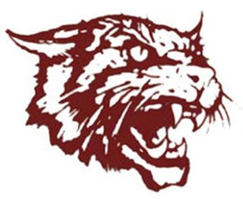
The Avon Grove Wildcats is a non-profit, volunteer youth football and cheerleading organization. Formed in 1993, the AG Wildcats strive to provide high quality, athletic instructional opportunities for the youth of our community, while emphasizing safety, competitiveness, good sportsmanship, and the importance of academic achievement.

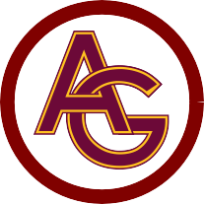
Our Sponsorship program is vital to the Wildcats Organization. The funds through this program help pay for equipment, uniforms, field maintenance and safety programs. Sponsoring the Wildcats is not only a way to support this Organization and community youth, but it will also provide local businesses large marketing exposure to a great demographic of hundreds of families in our local community.

2023 SPONSORSHIP PROGRAMS
- Grey – Company Logo on Website & Social Media, and Game Day Announcements ($250)
- Maroon - Company Logo on Website & Social Media, Game Day Announcements and Yard Sign ($500)
- Gold - Company Logo on Website & Social Media, Game Day Announcements and Fence Banner ($1,000)
- Wildcat - Company Logo placed on Website, Sign above Scoreboard and VIP Experience ($2,500)
- Friends of Wildcats - Any donation amount!
SPONSOR AGREEMENT

agrees to support the Avon Grove Wildcats. Your contribution shall be for uniforms; equipment; coach certifications and volunteer clearances; trophies; payment of all referees; and scholarships.
I understand the money is designated for the Avon Grove Wildcats Football and Cheerleading organization only and will be used in support of the program.

Please email this form and company logo to:
Mike Cohen, Treasurer of the Avon Grove Wildcats
Email: info@agwildcats.com Mailing Address: Avon Grove Wildcats, PO Box 103, West Grove, PA 19390

Please make checks payable to “Avon Grove Wildcats”
Venmo: @AG-Wildcats

$
Amount Sponsor’s Signature Date

Contact Name Address

Phone # Email

